Data Types and Keys

John Wensink

MIS407 Database Concepts

Colorado State University-Global Campus

Nathan Braun

July 26, 2019

Week 2 CT Option 1

"1. Write a CREATE TABLE statement for the Customer table. Choose data types appropriate for the DBMS used in your course. Note that the CustBal column contains numeric data. The currency symbols are not stored in the database. The CustFirstName and CustLastName columns are required (not null).

|  |  |
| --- | --- |
| CREATE TABLE cust |  |
| (CustNo | serial primary key CHAR(8), |
| CustFirstName | VARCHAR(50) CONSTRAINT CustFirstNameRequired NOT NULL, |
| CustLastName | VARCHAR(50) CONSTRAINT CustLastNameRequired NOT NULL, |
| CustCity | VARCHAR(50), |
| CustState | CHAR(2), |
| CustZip | CHAR(5), |
| CustBal | DECIMAL(10,2) ) |

(Mannino, 2019)

2. Write a CREATE TABLE statement for the Employee table. Choose data types appropriate for the DBMS used in your course. The EmpFirstName, EmpLastName, and EmpEMail columns are required (not null).

|  |  |
| --- | --- |
| CREATE TABLE emp |  |
| ( EmpNum | CHAR(8), |
| EmpFirstName | VARCHAR(50) CONSTRAINT EmpFirstNameRequired NOT NULL, |
| EmpLastName | VARCHAR(50) CONSTRAINT EmpLastNameRequired NOT NULL, |
| EmpPhone | CHAR(13), |
| EmpEmail | VARCHAR(50) CONSTRAINT EmpEmailRequired NOT NULL) |

(Mannino, 2019)

3. Write a CREATE TABLE statement for the OrderTbl table. Choose data types appropriate for the DBMS used in your course. The date column is required (not null).

|  |  |
| --- | --- |
| CREATE TABLE ord |  |
| ( OrdNum | CHAR(8), |
| OrdDate | CHAR(10) CONSTRAINT OrdDateRequired NOT NULL, |
| CustNo | CHAR(8), |
| EmpNo | CHAR(8)) |

(Mannino, 2019)

**Here is the SQL that I would input into PostgreSQL 10:**

CREATE TABLE cust (

CustNo serial primary key CHAR(8),

CustFirstName VARCHAR(50) CONSTRAINT CustFirstNameRequired NOT NULL,

CustLastName VARCHAR(50) CONSTRAINT CustFirstNameRequired NOT NULL,

CustCity VARCHAR(50),

CustState CHAR(2),

CustBal DECIMAL(10,2)

);

CREATE TABLE employee (

EmpNum serial primary key CHAR(8),

EmpFirstName VARCHAR(50) CONSTRAINT EmpFirstNameRequired NOT NULL,

EmpLastName VARCHAR(50) CONSTRAINT EmpLastNameRequired NOTNULL,

EmpPhone CHAR(13),

EmpEmail VARCHAR(50) CONSTRAINT EmpEmailRequired NOT NULL

);

CREATETABLE ord (

OrdNum serial primary key CHAR(8),

OrdDate DATE(CURRENT_DATE) CONSTRAINT OrdDateRequired NOT NULL,

CustNo CHAR(8),

EmpNum VARCHAR(8)

)

(Juba and Volkov, 2017)

**I would then resolve any syntax errors that are certain to pop up as this would have been my first experience at writing SQL inputs.**

4. Identify the foreign keys and draw a relationship diagram for the simplified Order Entry database. The CustNo column references the Customer table and the EmpNo column references the Employee table. For each relationship, identify the parent table and the child table.

(IMAGE BELOW)

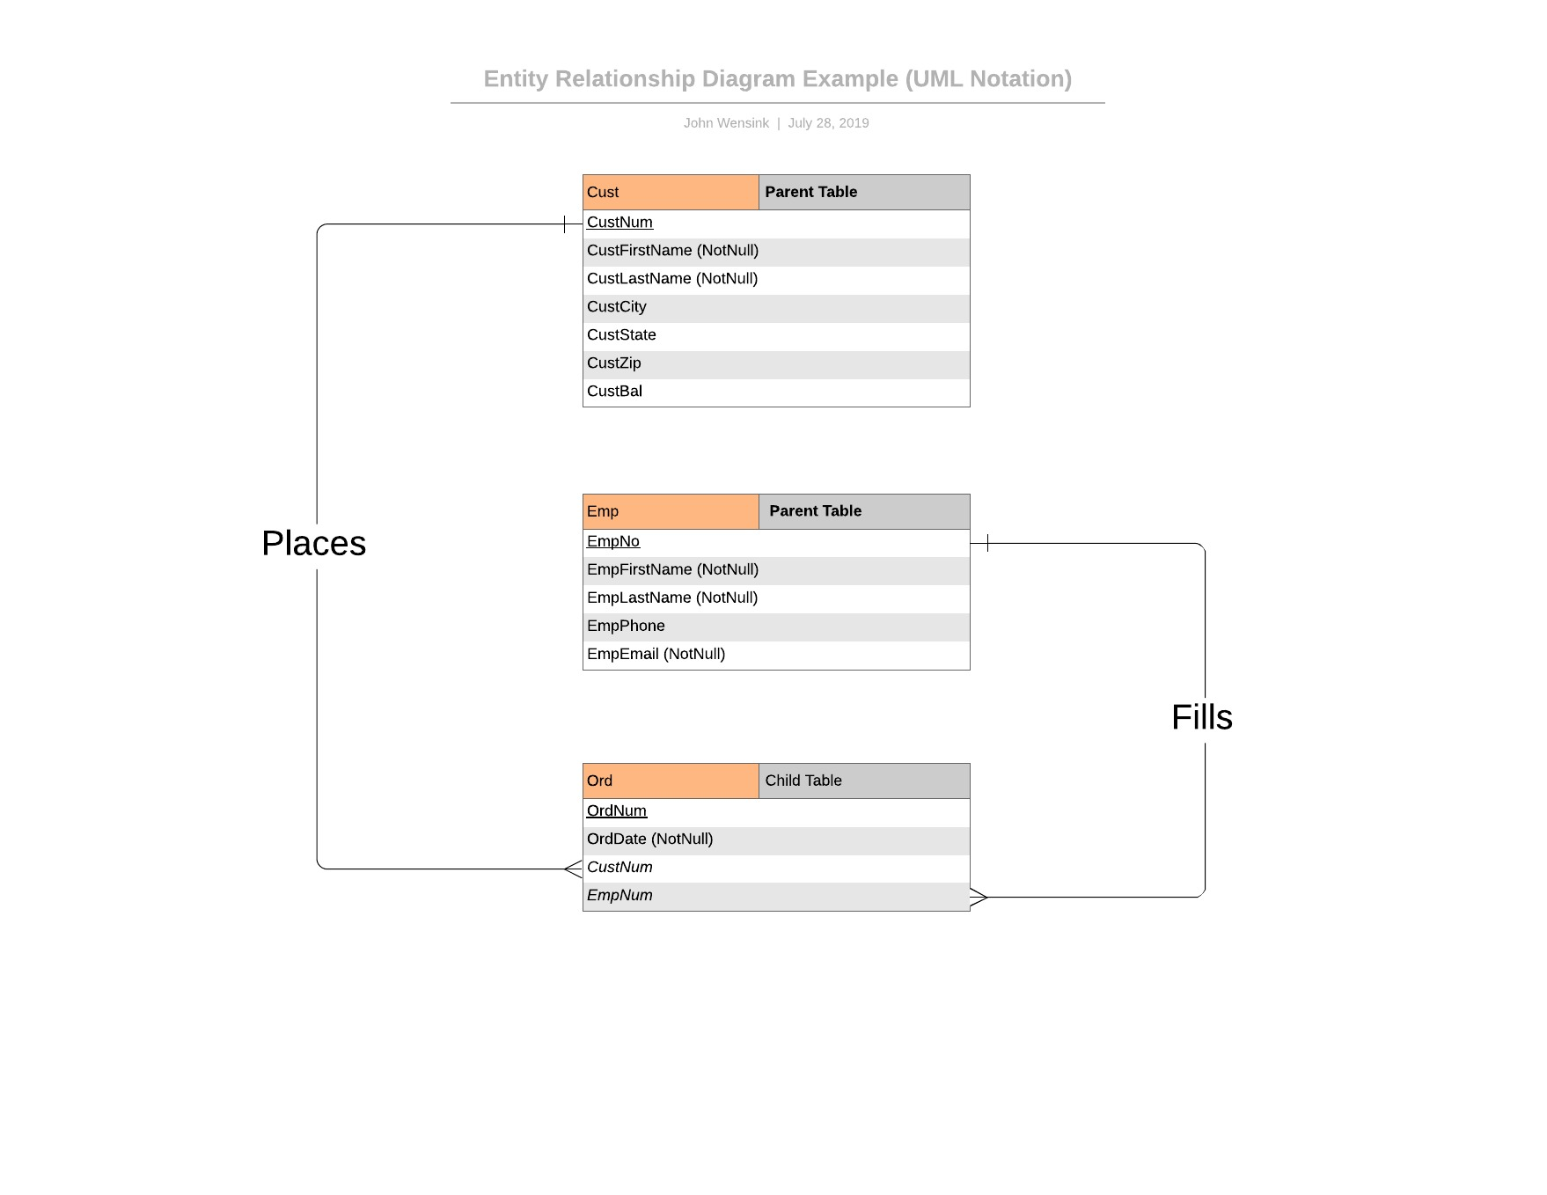

5: A brief discussion on the primary challenges, if any, you experienced in completing this assignment:

I found this exercise extremely helpful but I am worried that my relationship diagram is too simple. From previous experience in Python, I know that simple is good but I can’t help but feel like I’m missing something. Writing the SQL into a text document is surely meant to simplify the exercise for beginners, however, not using PostgreSQL I have no idea if my syntax is valid or not. Perhaps I will dive into the database program to test my code once I finish this week’s required reading and discussion posts. I have worked with LucidChart for a previous course’s portfolio project and find it intuitive and powerful to use. I am interested to see how we can manipulate the chart into actual tables using a computer-aided software engineering (CASE) application. I have found the text Database Design easy to read and at my level of learning. I had a difficult time understanding the practical differences in join operations and not sure when one would be more useful than another. One thing that has been bugging me, however, is that the Understanding PostgreSQL text goes over a great deal of technical detail, but the CT assignments only touch on a small fraction of what is presented. I am concerned that my inexperience with relational algebra functions will hinder my learning in later chapters without practicing them. I am trying to learn this to get promoted into an IT position within my company and am concerned that I’m not going to be a master of the subject matter in eight short weeks. I trust that the course is set up properly and that the skills will come with practice. Looking forward to later modules being more challenging as I never had a moment where I was yelling at my laptop this week.

References

Juba, S., & Volkov, A. (2017). *Learning PostgreSQL 10*(2nd ed.). Birmingham, UK: Packt Publishing. Retrieved July 24, 2019, from [https://platform.virdocs.com/r/s/0/doc/592940/sp/46536422/mi/192431128?cfi=%2F4%2F8](https://platform.virdocs.com/r/s/0/doc/592940/sp/46536422/mi/192431128?cfi=%2F4%2F8&menu=table-of-contents)

Mannino, M. (2019). *Database design, application development, and administration* (7th ed.). Retrieved July 24, 2019, from

<https://platform.virdocs.com/r/s/0/doc/592088/sp/46211794/mi/190879329?cfi=%2F4%2F8>